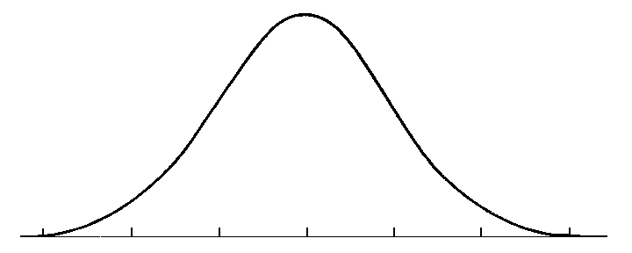
Math 243 – Statistics I – T/Th 2pm
Term: Spring 2019

Course Information
Portland Community College – Southeast Campus
2305 SE 82nd Ave., Portland, OR 97216
Math 243, CRN 25325, 5 credits
Day/Time: T,Th 9-11:20am
Room: SCOM 200

Instructor Information
Instructor: Cara Lee
Office: Student Commons 214
Phone/Voice Mail: 971-722-3773
Email: cara.lee@pcc.edu
Notes Website: Notes Website
Student Office Hours:
- Mon, Tues, Thurs, 11:30am-12:30pm in SCOM 214
- Wed, 11:30am-1:30pm in the Tutoring Center in the Library (1st floor)
- and by appointment, just ask!

Welcome! You belong here!
I value differences and appreciate working with students of all races, ethnicities, ages, sexual orientations, gender identities and expressions, abilities, sizes, shapes, socio-economic backgrounds and educational backgrounds. I plan to learn as much from you as I hope you will learn from the experience of this class. PCC is a sanctuary college and you can read more on this web page for undocumented students.


Teaching Philosophy
You already have experience with statistics from your daily life and the media and we will be drawing from that. I think the study of statistics is critical for employment and being a consumer in the information age. There is more data being collected about us than ever before. Statistics involves calculation but more importantly, interpretation and critical thinking. You will be writing in this class! We will have discussions because there are many grey areas. You will be learning frameworks for interpretation. There can be multiple right answers if they are supported by critical thinking consistent with the frameworks discussed in class. We will be exploring social justice themes.

Grading Philosophy
You are a person separate from your grade. A grade is a measure of skills and the communication of those skills. I am always on your side and I am looking for everything that you do right. It is better to write something than nothing. I will do my best to provide useful feedback on your work so you can learn. I encourage you to form study groups and work together. On individual assignments, you must write up your work in your own way. No two papers should look identical.

Course Description
Introduces displaying data with graphs, numerical descriptions of data, producing data, elementary probability, probability distributions, confidence intervals and significance testing. Investigates applications from science, business, and social science perspectives.
Link to Description, Outcomes and Course Content.
Prerequisites: MTH 95 or MTH 98 and placement into WR 121.
Sidenote
“Statistics is the science of variation,”~ Douglas M. Bates
End Sidenote

Required Materials:

Free Online Textbook:
Advanced High School Statistics, Diez, Link to free online textbook (Written for Advanced Placement Statistics). Inexpensive print copies are available in the bookstore.

Free Online Homework System:
Link to MyOpenMath.com
Create a student account, enter this Course ID: 47167, and this enrollment key: math243spring2019

Technology:
- Any scientific calculator with a square root button. (No phones on tests, no graphing calculator needed)
- Free GeoGebra download (Version 5 download is recommended)
Link to Free GeoGebra.org
- Free Microsoft Office for students
Link to Free Microsoft Office

Other Materials:
3-ring binder with dividers, paper, pencils, erasers, pencil sharpener, mini-stapler

Grading and Other Course Policies
Course grades will be calculated as follows. You can check your grade in the gradebook in MyOpenMath.
Course Components | Points
Written Assignments and Quizzes | 95 (17%)
MyOpenMath Online Homework | 100 (17%)
Team Project | 50 (9%)
Midterm 1 | 100 (18%)
Midterm 2 | 100 (18%)
Final Exam* | 120* (21%)
Total | 565
*You must score 65% or higher on the final to pass the course with an A, B, or C.
Percentage of Total Points: | Course Grade:
90% | A
80% | B
70% | C
60% | D
59% and below | F
The lowest score from the graded assignments and/or quizzes will be dropped to allow for absences and emergencies. You also have 5 late passes in MyOpenMath. These will extend the deadline for an online homework assignment. If past the late pass window, email Cara to use it.
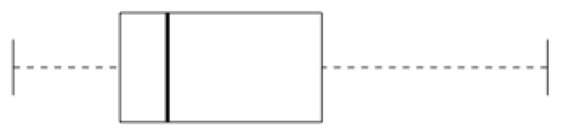
You can check your scores and overall grade at any time in MyOpenMath. Check to make sure that your scores match what is in the gradebook.

Make-up policy
Class attendance and engagement is very important for your success. Communication is the most important thing if you are sick or have an emergency. You need to complete all work to be successful in the class. Read below for specific scenarios.

What do I do if...
- I am late for class: Please come in at any time! It is better to come for any part of class than not at all. If persistent lateness becomes an issue we will talk about it. Notify a classmate or the instructor if you are able but this is not required.
- I need to leave early: Please let me know during class or by email.
- I will be absent: Please let me know beforehand or afterward, as soon as you are able. Go to the Notes Website (Notes will also be available in D2L) and get any resources from that day after they are posted (usually by the end of the class day). Complete the notes and activities and meet with me or a tutor to get any questions answered.
- I will be absent and an assignment is due: Please turn it in or email it to me by the end of the day. If you are not able to complete it then email me to make arrangements by the end of the day.
- I missed MyOpenMath deadlines: You have 5 late passes inside MyOpenMath, which will extend your deadline. If it’s past the window, email me to use them. There are also extra credit review problems to make up lost points. If you have missed more than that please talk with me.
- I miss a quiz or a test: Please let me know in advance, or as soon as possible in an emergency. Do not wait until the next class because I want to give the quiz or test back. Make an appointment with the testing center and let me know when your appointment is. Let the testing center know if you need to cancel or reschedule an appointment.
  - Testing Center Info: Student Commons 118, testing.se@pcc.edu, 971-722-6277 or 6253. Bring a photo ID. Testing Center Locations and Hours
- Class is cancelled due to weather, instructor illness or other circumstances: Please check your email as soon as you are able. We will not get to make up class time, so I will send resources and instructions for you to complete the homework and stay on schedule.
- I feel lost, behind or frustrated with the class: Please talk to me or email me. I have been there, too, and I am here to help you. It’s better to get help as soon as possible. Don’t spin your wheels. Sometimes people think they don’t belong in college, but that’s not true. Getting stuck and working through it is part of college. It just takes college experience to know that. You can also talk with classmates and use other campus resources. Use my office hours, the tutoring center and free online tutoring.
Food and Drink. You may have beverages and cold snacks. Make sure you leave the classroom neat for the next class. Please do not bring hot food or other items that may disturb or distract others.
Sidenote
“All models are wrong-but some are useful,” ~ George Box
End Sidenote

Graded Course Components
The suggested study guideline is 2 hours of homework/studying for each hour in class (10 hours/week for our class). This varies by student, so you may need more or less time.

Written Assignments:
There will be a few written problem sets due at the beginning of class as indicated on the course calendar. These problem sets are your chance to show your best work and get feedback. There will be some team and some individual assignments. For team assignments you will turn in one copy for the group. For individual assignments you are encouraged to work with your classmates, but each person must write up their own work. No two papers should look identical.

Quizzes:
Quizzes will be given about every other week as indicated on the course calendar. Complete your online homework and class notes and use them to study for the quizzes. These will help you stay up to speed and prepare for the tests in smaller chunks.

MyOpenMath Online Homework:
Online homework assignments are due as shown on the course calendar and inside our course MyOpenMath shell. Do your best to complete the homework problems for each section covered in class before the next time class meets. The next day’s material will often build upon the last. Write the steps down in your notebook or print a copy of the homework problems and write your work on that paper. Then you can use your work to study for the quizzes and tests.
If you get stuck or have a question, post it to the forum using the link at the bottom of the problem. You can respond to other students’ questions and I will also respond. You can also get help in the tutoring center. You can ask a tutor to go to the computer with you for help.
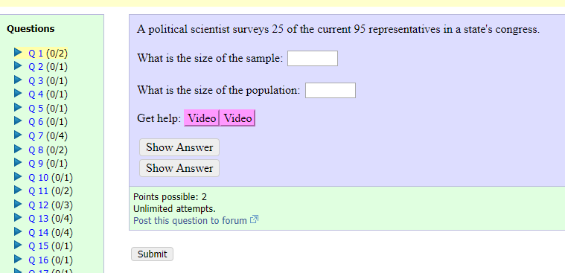

Team Project:
There will be one team project as indicated on the course calendar. More details will be given in class.

Tests:
There will be two midterms and a cumulative final test. Test dates are shown on the course calendar. Completing class notes and activities and the online homework is the best way to prepare for the tests. If testing anxiety or math anxiety are a concern for you, we have campus resources to help. Please talk with me early in the term.

Extra Credit Policy:
About 15 bonus points are available in MyOpenMath as review problems, or about 3% of the course points. Extra credit is not a substitute for regular course work, which must be completed to succeed.

Use the Learning Center:
There is free face-to-face tutoring in the Library on the 1st floor and free eTutoring you can access: Link to free etutoring.

Important College Policies and Information

Title IX/Non-Discrimination
Portland Community College is committed to creating and fostering a learning and working environment based on open communication and mutual respect. If you believe you have encountered sexual harassment, sexual misconduct, sexual assault, or discrimination based on race, color, religion, age, national origin, veteran status, sex, sexual orientation, gender identity, or disability please contact the Office of Equity and Inclusion at (971) 722-5840 or equity.inclusion@pcc.edu. You can read more and find a confidential reporting form at the Equity and Inclusion Web page.
You are also welcome to talk to me, just know that all instructors are mandatory reporters for Title IX and child abuse issues to the college. You may speak with designated confidential people such as counselors in SCOM and staff in the Women’s Resource Center and the Queer Resource Center. I would be happy to walk with you to the place of your choice.
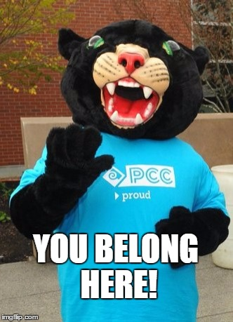

Listening Intervention Team for Equity (LITE)
LITE is a PCC resource for students, faculty, and staff who have experienced inequity or need guidance to navigate challenging dynamics at the college across cultures, races, ethnicities, gender identity or expression, sexual orientations, ability, faiths, and other aspects of identity. The LITE listener will offer compassion, help you process your experiences, share skill-building techniques and problem-solving strategies, and connect you with other existing support resources. To talk to a LITE listener about experiences of inequity you have had at PCC, go to the web page for LITE Listeners ,then click on a coordinator or listener name for contact information.

Sanctuary College
PCC promotes the success, dignity, and worth of every individual by providing a safe environment where the examination of divergent ideas, experiences and systems of inequality adds depth to the learning experience. PCC strives to provide opportunity to all students and the appropriate level of support services to ensure the highest level of success. For more information and resources, see the web page for undocumented students.

FERPA (Family Education Rights and Privacy Act)
You have the right to privacy of your personal information and educational records. I can only send email to your secure MyPCC email account so that I am communicating with you confidentially.

Accessibility
If you are working with Disability Services I will be happy to work with you on your accommodations, just let me know. If you believe you may need an accommodation you can start the process at the web page for disability services.

Inclement weather or emergencies
Campus closures will be announced on TV, radio, www.pcc.edu, and the college switchboard, 971-722-6111. Check your email for details on making up class materials.

Audits
Students must obtain instructor permission to audit a course by the deadline posted by the college.

Registration and Dropping
Students may attend this course only if registered. Students who are unable to attend must drop the course online or through the Registration Office. To have tuition charges removed, the course must be dropped by the student before the drop deadline posted on MyPCC and in the class schedule. Students who stop attending without dropping will receive a grade of F due to college policy.

Drop and Withdrawal Deadlines
web page for drop and withdrawal deadlines

Pass/No Pass Grades
Choose a grading option of letter grade (A-F), or Pass/No Pass (P/NP) via the computer registration system by the deadline posted by the college. Talk with your advisor as some degree/certification programs may not accept Pass/No pass grades.

Incompletes
Incompletes are rarely given, and allowed only if at least 75% of the work is already completed, with a current grade of "C" or above. A contract for completion must be signed by the student and instructor to receive an incomplete.

Academic Integrity
Being a successful student and living successfully requires you to develop a strong sense of personal and professional integrity. Completing your own academic work is a requirement of PCC. Students that engage in any form of academic dishonesty may receive a zero for that test or assignment. Further academic dishonesty may result in an F for the class and charges for violation of the Student Conduct Code.
PCC Grading Guidelines
PCC Student Code of Conduct

Southeast Campus Resources
Student resources website

Library
- Check out books, calculators, laptops, 1st floor desk
- Tutoring Center and Computer Lab, 1st Floor
- Reading and Writing Center, Library 218

Tabor Hall
- Student Resource Information: ASPCC Hub
- Panther Food Pantry and Emergency Bus Tickets: Tabor 105
- Veteran’s Resource Center: Tabor 120
- Career Exploration Center, Jobs and Internships: Tabor 147
- Women’s Resource Center and Lifetracks Program: Tabor 148
- Queer Resource Center: Tabor 149
- Multicultural Center: Tabor 150
- Bike Rentals, Childcare Grants, Clubs, ASPCC: Tabor 152
- Public Safety and Lost and Found: Tabor 153

Student Commons Building (SCOM)
- Disability Services: SCOM 112
- Advising: SCOM 116, Schedule at Information Desk
- Counseling, up to 8 free sessions: SCOM Info Desk or 971-722-6240

PCC Links
- Free online tutoring
- Emergency grants
- Childcare center

Community Resources
- Call to Safety Website, 503-235-5333
- Aunt Bertha Website, 211.org
- Columbia County Mental Health Line, 503-397-6161
- Washington County Crisis Line, 503-291-9111
- Yamhill County Crisis Line, 503-434-7523,
- Clackamas County 24-hour Crisis Line, 503-654-2288

Math 243 Calendar – 2pm Class
Dates | Tuesday | Thursday | MyOpenMath  Due the next Tuesday or Thursday by 11:59pm
Apr 2, 4  Week 1 | Course Introduction  Sections 1.1-1.2  Assignment 1 handed out (Team) | Student Info Sheet Due  Sections 1.3-1.5 | MyOpenMath orientation,  1.1-1.2, 1.3-1.5
Apr 9, 11  Week 2 | Sections 2.1.2-2.2.5 | Assignment 1 due (One copy per team)  Sections 2.2.2, 2.2.7 | 2.1.2-2.2.5, 2.2.2, 2.2.7
Apr 16, 18  Week 3 | Quiz 1 (Chapter 1 and 2.1.2-2.2.5 packet)  Section 3.1  Review 1 handout | Sections 3.2 (includes 2.3) | 3.1, Midterm 1 bonus problems open until the final
Apr 23, 25  Week 4 | 1st Midterm  Chapters 1-3.1 | Section 3.5  Assignment 2 handed out (Individual) | 3.2, 3.5
Apr 30, May 2  Week 5 | Inservice Day  No classes that start before 4pm. Campus and tutoring open | Quiz 2 (3.2, 3.5)  Section 4.4  Team Project handed out | 4.4
May 7, 9  Week 6 | Section 4.1 | Assignment 2 due  Section 4.2 | 4.1
May 14, 16  Week 7 | Quiz 3 (4.4, 4.1)  Sections 4.2 and 4.5  Review 2 handout | Section 4.5  Assignment 3 handed out | 4.2, Midterm 2 bonus problems open until the final
May 21, 23  Week 8 | 2nd Midterm  Sections 3.2, 3.5, 4.4, 4.1, 4.2 | Sections 5.1-5.2, 6.1 | 4.5, 5.1-5.2, 6.1
May 28, 30  Week 9 | Assignment 3 due  Sections 5.3-5.4, 6.1 | Quiz 4 (4.5, 5.1-5.2, 6.1)  Sections 8.1-8.2.6 Part 1 | 5.3-5.4, 6.1, 8.1-8.2 Part 1
Jun 4, 6  Week 10 | Project Due  Sections 8.1-8.2.6 Part 2  Final review handed out | Catch-up and  Review for the Final | 8.1-8.2 Part 2, All bonus review problems
Jun 11, 13  Finals Week | No Class | Final Exam  (Cumulative)

This schedule is tentative and subject to change due to class circumstances, weather, etc. Updates will be given in class and online. Check your MyPCC email frequently.

