EXTRACTS FROM AN HONOURABLE FAKE
I wrote An Honourable Fake back in 2017 in the hope that Africa might soon see the emergence of a political hero who could reverse its long history of poverty and corruption and face up to increasing Islamic terrorism spreading from the north. In 2026 it seems we are still waiting.
An Honourable Fake was the second book in the Asher & Asher series.
It’s a longish book (105,000 words)

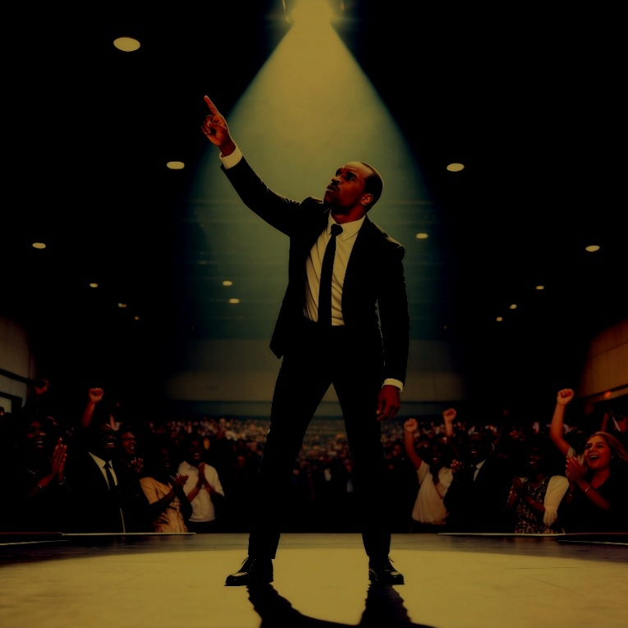

Excerpt from Chapter 2
Gabriel in California talking to the State Governor.
Gabriel didn’t like the way he was speaking right now. It was unnatural, but it was deliberate. It was like acting. Preaching was an act as well. He would often change his tone, his accent, and his style to reflect who he was speaking to and why. Right now, he was talking to a high-flying, rich American politician who he knew would not bother listening to soft words, sensitive phrases, and politeness. This man wanted to be impressed. It was a time for rough talk some American slang and a tone that suggested impatience, overconfidence, and brashness. Delivered like that, this man would be far more likely to buy into it. Preaching about prosperity gospel was, after all, pure salesmanship.
“The preaching business has changed since the Lord Jesus walked among us,” Gabriel went on. “He may not be happy with what some of the customers of his competitor Mohamed get up to, but I don’t blame Mohamed for that. It’s his preachers and the millions of disaffected youths who follow them who have a lot to answer for. It must hurt him lots. Mohamed was an OK guy. It’s his new brand of messengers that hurt him.
He paused to let the governor speak but he said nothing.
“So, you’re getting to know what the message is now, right, sir? It’s that material and financial betterment now meets with God’s full approval. Even he couldn’t hold back the tide, you see—it’s human nature. It’s not like it once was. For many black Americans and their African cousins, materialism fits neatly into their lives. The spiritual world still manifests itself in their everyday lives, but nowadays, it’s all about creating wealth. But that’s damn hard if your livelihood and personal safety is at risk, if all your hard work is exploited by the rich and the powerful and you’ve got no confidence in the future.
“So, you and your friends in Congress need to get with it, man. The old Christianity brought to Africa in the nineteenth century was Western. As someone once said, the old view was concerned with dualism - the dualism between the mind and the spirit, between this world and the next, between God and the devil, between the simple matter of day-to-day living and surviving and the soul.
“Africa’s where the missionaries went, but they didn’t finish their job, and it’s too late now because the world moved on. It ain’t as simple as it was. America is stuck. Europe is stuck. They’re so stuck they can’t change any more. They can’t even deal with their own problems because they’ve bound themselves up in red tape, social support they can’t afford and all that human rights shit.
“But did you hear the cheering last night, Governor? Did you listen deep? I never hide my message. If it makes for uncomfortable listening, then so be it. But if you want to stop this rot, this plague of terrorism, this economic sickness, and this epidemic of uncontrolled population growth and unemployment, you gotta understand that in African minds, that old simple dualism I mentioned is gone. It’s gone forever, my friend. It ain’t there anymore.
“They now worship wealth and money like it’s the Lord himself. It’s why they like my Italian suit, my silk tie, and my silky way with words. The suits are my uniform. It’s what’s necessary in modern show business, but they can’t get anything for themselves without freedom, and they won’t get freedom until they get leadership. They need a different sort of leadership, one that accepts the reality that the world faces genuine threats to its survival without some serious action.
“So, you understand my direction, Governor? Spiritual leadership works, Governor. It’s seriously lacking in the world right now, but it stirs folk into greater optimism. It makes them get up on a morning and go to work because they see a reason. They even work harder. Christian leadership, maybe even Christianity itself, is not cool enough anymore. You gotta make it cool. You gotta match them others—them others who think their way is so fucking cool that they even believe the earth is flat, that the sun rotates around the earth, and that God provides virgins for fulfilment after death. Their only objective is to sow seeds of discord, but it’s become so cool they leave home, go pick up a gun, and fix a grenade to their underwear. Sowing seeds of discord is now more cool than sowing seeds of liberalism and freedom.
“While you argue about the economy, jobs, health care, education and your own local problem over lack of water and while your government reluctantly sends a few US Marines to help stick pins in what remains of Bin Laden’s legacy, you know what’s going on under your nose?
“Where I come from five years have gone by since they said they’d halted the expansion of terrorist groups like Boko Haram. ‘They are defeated’ was the call. Two years later, it was ‘We are driving them back.’ Last year, it was ‘There are only a few pockets left.’ Whoever said all that, sir, was only after one thing—re-election to cloud cuckoo land. Because while they were dreaming up fresh words to pacify the masses, fresh wildfires of terrorism and social unrest were breaking out everywhere—the Middle East, Africa, the Far East. It was a mess then, and it’s a worse mess now. All the West does is hand out aid to make them feel better or pretend that bombing targets work when it really knows that only boots on the ground are effective. And meanwhile, economies stagnate, and the poor get poorer.
“Globalisation is what we’ve got here, Governor. Globalisation of the economy has led to globalisation of terrorism because globalisation fails the poor. And you know what the poor do when they got nothing better to do, Governor? They fuck, they breed, they reproduce. And what happens when you fuck and breed and you run out of food and water and you no longer have the means to support yourself? You migrate, or you join those that offer jobs with guns. Or you do both—migrate and take up guns.
“You and your friends up there in Congress need to start to understand why we’re where we are, and you can then move to the second question of how to deal with it.
“And why am I here again—my sincere thanks for the bed, breakfast, and other services, by the way, Governor. Why? Because my plans for dealing with the how are nearing completion. On my own, Governor. Got it? If I can get this far alone, think what the US, the EU, or the UN could do if it really put its mind to it. I know you already heard some, but it’s getting scary now, sir, ’cause I’m now ready. But Gabriel don’t scare too easy.
“So, Governor, you want part of my scary plan or not? Are you now convinced enough to take the president aside, whisper in his ear, and tell him that Africans have no wish to go back five hundred years, but that they, too, want to head toward that bright light of the future he keeps talking about.
“Tell him that the world’s economic system is failing, sir. Tell him that social unrest, fundamentalism, terrorism, or corruption is like a parasite, sir. It’s like a tapeworm that grows longer and longer inside and sucks the blood of the wealth created by the innocent poor. Tell him that the only way to kill this parasite is to change the system that widens the gap between the rich and the poor, between the haves and the have-nots and provide the protection for people to build their own lives in their own way. That’s real freedom, sir, and I once thought the US understood that word.

Extract from the Chapter where Mark Dobson from Asher & Asher comes face to face with front line criminals at Pink Lips – a Lagos nightclub

"Pink Lips," Chelsea announced. "Disco downstairs, casino upstairs, bar ground floor."
Dobson was in no mood for either dancing, gambling or drinking. What he wanted was a fresh look at a meeting place famous for dubious deals, exchanging stolen goods and other, mostly nocturnal, activities. If it looked good, he might order a job to be done.
They waded in. It wasn't quite how Dobson remembered from a few years ago, but it had been night time and combined with a power failure. He could now see that, given an electrical supply, it would have advertised its presence by pink neon lights in the shape of pouting lips, dancing legs and high-heeled shoes. It had once been a large and expensive countryside villa before being overtaken by the mess of urban growth, but big money was clearly being made somehow for two new Mercedes cars and three Toyota mini buses were parked at the side, and a group of men in open necked shirts stood beneath an awning as water cascaded in front of them.
One of them stood out - a big man in a damp looking suit and a bright pink shirt. His eyes blinked rapidly and his nose twitched as if he'd just surfaced from a short underwater swim. A gaggle of girls in high heels, short, tight skirts and complicated hair styles stood beside him holding onto one another and giggling. Pink, Dobson noticed, was the dominant colour - pink shoes, pink ribbons and big pink lips. Cigarette smoke wafted upwards.
Chelsea did introductions. "Hey, Benji, This akata with the job? Him rich, rich, Benji. Got big sense."
The girls stopped giggling but didn't stop holding onto each other.
"Need full pocket at Pink Lips," Benji said with what Dobson assumed was a sense of humour. The other men joined in the humour, the girls giggled again and a brave one piped up with, "Woss your label, honey?", which was so funny that they giggled some more and rolled big black eyes in Dobson's direction.
Dobson had no problem ignoring this but held out his hand towards the one he assumed was Benji. "Simon Smith," he said. The other men came closer, checking him out - big suits, colourful shirts.
"Yeh, sure. I heard about Mr Smith," Benji said. "I met some others. Big family. You got any other pseudonyms man?"
"Can you make do with Simon Smith?"
"Sure, sure. Enta, come on in. We tock. Simple Simon met a pie-man. You heard that song?"
"Yes," Dobson confirmed. "When I was in nursery."
The other suits stayed by the door - four men, four different sizes, four shirt colours, the biggest one in fluorescent pink who still blinked. But it was only one eye, winking not blinking. Dobson glanced back thankful to see he was winking at everyone, an affliction of some sort, but disturbing nevertheless.
The music got louder when Benji opened the front door and beckoned them inside. "Enta, enta."
Fluorescent pink shirt winked again and stepped forward as if he would be joining in. But then he withdrew as if he’d smelled something not to his taste.
"Nice music," Dobson lied, hoping he sounded convincing.
"Soul train on steroids," laughed Benji, "You wanna come Sattaday night. Like blazing fiya. More bubble as well." It sounded like a sales pitch.
"This your place?" was Dobson's next piece of small talk.
"Me and another rich fella."
"Like the one outside?"
"Pink Panta?" Benji said. "Nah. Pink, he organizes da ladies. I can call him. You wanna flex your stick?"
"Not right now," Dobson said.
The place smelled of beer, cigarette smoke and sweat. There was a stage where two girls in black underwear and pink belts were dancing with no-one watching. Perhaps they were practicing. Tables were set around and, in one corner, was a bar surrounded by coloured lights. But the place was empty and the barman was reading a newspaper.
"Seedan," Benji pointed to a vacant table. "You want sumtin' fizzy?"
Dobson would have been fine with a glass of water but: "I'll have whatever you and Zak drink," he said. Benji beckoned the barman and ordered three Star Lites.
Chelsea got excited. "They have food also, Mr Dob........Mr Smith. Tasty fish and fries." Dobson ignored him.
"So, what kind of business, Mr, uh, Smith?" Benji loosened his collar, smoothed his unevenly shaved, flabby cheeks, sniffed and wiped his nose between finger and thumb. Perhaps it was rainwater.
Benji was older and fatter than Dobson had imagined. He sported a touch of grey in his hair, but the part that fitted his imagination was the gold cross on a chain around his neck. It dangled outside the open top buttons of a red striped shirt. Rainwater had darkened the shoulders of his ill-fitting suit jacket.
"Information business," Dobson shouted over the music. "When we get information, we act."
"If I see blood, mean plenty ego, man. You pay Naira or dollah?"
"Naira to start but let's see how we get on."
"One hundred thousand for open ear, OK?"
Dobson deliberately raised an eyebrow though he'd already ring-fenced Solomon's upfront payment for occasions like this and money from the warehouse stock would help. Just yet, money didn't matter too much. He sat forward, felt in his back pocket, pulled out a bundle of notes, counted a few and put them on the table. "Seventy. If I like answers I find more."
Benji picked it up and counted it, slowly, eyeing Dobson as if the notes might be forged. Dobson sat back, waited and reflected on what he was about to do. The reflection was longer than expected because Benji miscounted the notes and started again, licking his fingers for better grip. Finally, he looked up. "OK, my ear open. Smoke?"
"No, thanks."
"Marry J?"
Dobson declined the marijuana. His eyes were already smarting. Instead, he leaned across the table. Chelsea copied and their heads almost collided. "An English friend of mine was abducted and robbed at the airport here a few weeks ago," he shouted into Benji's face, the wide, faintly pink eyes staring back at him from six inches away. "The guy was on his way to do business with a company called Solomon Trading - you heard of them? But he never got there. He went back home to London because he was too nervous to come again. I've taken over."
Benji sat back, blew smoke from the corner of his mouth. "Too bad. Big shame."
"I want to know who was behind it."
Arms outstretched. "How the fuck do I.......?"
"It was organised from here - Pink Lips."
"Is that so?" Benji's arms came together again, his eyes widened and he took a suck on his cigarette, blowing smoke over Dobson's head.
"You know how I know?" Dobson shouted as the music unexpectedly stopped.
"Go ahead, feel easy."
"Zak did it."
Benji's stare moved to Chelsea. "Is that so? This zombie, did it?”
"And an excellent abduction and robbery job it was, too, if I may say so."
Chelsea rose visibly in his seat but then looked at Dobson, perhaps shocked at the way things were going. "Right, Zak?" Dobson said and Chelsea nodded, swirling a mouthful of Star Lite inside his mouth.
"Is that so?"
"But Zak doesn't know who ordered the job. He got instructions from Danny. Who ordered the job, Benji? And why. That's what I need to know. By the way..........." He fished in his pocket and pulled out another wad. "Here's another fifty because I like the way you're listening."
Benji picked it up. Tested the thickness of the wad but didn't bother counting it this time. Maybe he’d remembered he couldn't count too well.
"Danny's in Abuja,” he said. “He runs Pink Lips Abuja, but he was down this way some time back. Anyway, what's with Solomon Trading. Is that Pastor Gabriel?"
Dobson grinned. "I knew I'd come to the right place, Benji. Correct. Gabriel's the chairman. He's the brains, and my friend who got robbed was here to help him do some business. Gabriel's a big celebrity, a friend of the President of the USA and the British Prime Minister. He knew Nelson Mandela and Tony Blair. He doesn't deserve this. So why the fuck would someone stop my friend coming to Lagos to see him?"
Benji shook his head, puffed smoke, but he was definitely listening.
"Zak only did what he was asked," Dobson went on, rubbing things in further. "But he wouldn't have robbed my English friend if he'd known Pastor Gabriel was involved. You like Pastor Gabriel, right Zak?"
Chelsea choked on his beer but nodded.
"So, what I want to know is who is behind all this. Who paid for my friend to be robbed and nearly killed and who made him so scared shitless he went home to rest and get treatment for his concussion?"
"That your question, Mr Smith?" Benji shouted.
"Names. Then we decide what to do."
Benji leaned back and hauled a gold-coloured I-Phone from his pocket, swiped it and pressed a number as Chelsea looked at it in awe.
"Danny boy. Benji. How's it hanging? You hear me? Fuck, hang on. I'll go outside." He beckoned to Dobson to stay seated and disappeared. The coloured shirts were still there, lurking. Fluorescent pink was still winking as if he'd been winking so long to attract customers he couldn't stop.
"Comfortable so far, Chelsea boy?" Dobson checked.
Chelsea nodded, peering over his Star Lite bottle.
"It's looking expensive," Dobson added.
"So how do I work out my commission, Mr Dob......Smith?"
"You don't work it out, Scumbag. I do. What's my name?"
"Simon Smith sah."
"Until further notice. Got it?
"Yessah."
Benji returned amongst a gang of young Nigerian boys no older than fifteen. They went straight to the bar, crowded around it, shouting above the music. To Dobson it looked like they'd just struck rich in the street somehow and were now ready to spend it before anyone came looking for it. Benji sat down.
"Danny remembers. But he wants a share."
"What does he remember?"
"You need to talk man to man. He's in Abuja."
"Can't we talk on the phone? I pay you, you pay him."
"You gotta phone?"
"Yes, but Zak's phone's better."
Danny, it turned it, didn’t know who’d issued the instruction, it could have been anyone, but he had names, some familiar, others not. The names he didn’t recognise, Dobson mentally added to the Obodi list.
“And Godwin, sah.” Danny had added at the end like an afterthought.
“Godwin? Who’s Godwin?”
Danny seemed vague. “Godwin is Godwin.
Dobson logged it but, so far, the name meant nothing.

