Erica cinerea (Bell Heather) at Ainsdale Sand Dunes National Nature Reserve on the Sefton Coast, Merseyside (v.c.59 South Lancashire)
PHILIP H. SMITH
On 30th July 2024, the Site Manager for Ainsdale Sand Dunes NNR, Dave Mercer, exited his vehicle in a conifer plantation firebreak and found himself standing next to a patch of Erica cinerea (Bell Heather) in full flower (Figures 1, 2, 3). He drew it to the attention of the SSSI Responsible Officer, Natalie Hunt, who photographed the plant on 2nd August. Being under the impression that there were no records of E. cinerea for the Sefton dune system, Natalie contacted me. I confirmed that my Vascular Plant Inventory for the Sefton Coast (Smith, 2023) did not include E. cinerea and arranged a visit to the site, with Dave, on 8th August. I checked the identification, took a National Grid Reference, measured the dimensions of the patch, listed associated vascular plants and bryophytes with their relative frequency and took five sub-surface soil samples around the patch for pH determination, using a Lutron PH-212 meter buffered at pH4. Keys and descriptions in Rodwell (2000) were consulted to identify the likely plant community.
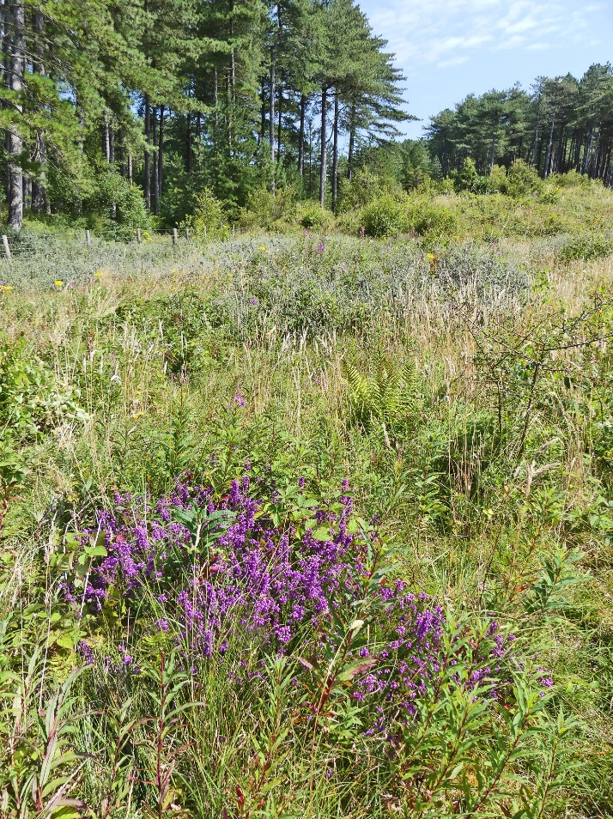
Figure 1. Site of Erica cinerea in NNR firebreak (N. Hunt)
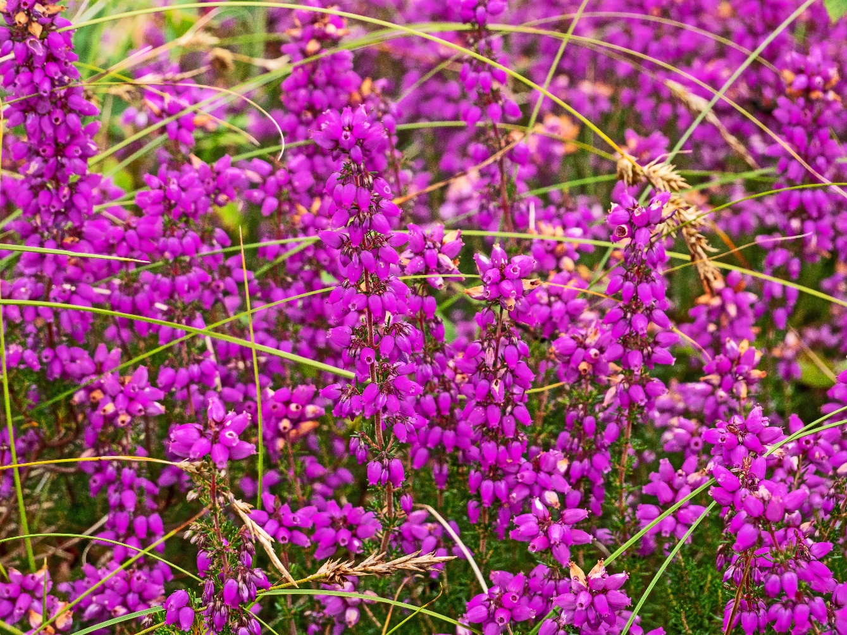
Figure 2. Erica cinerea with Carex arenaria (Sand Sedge), Ainsdale NNR, 8th August 2024.
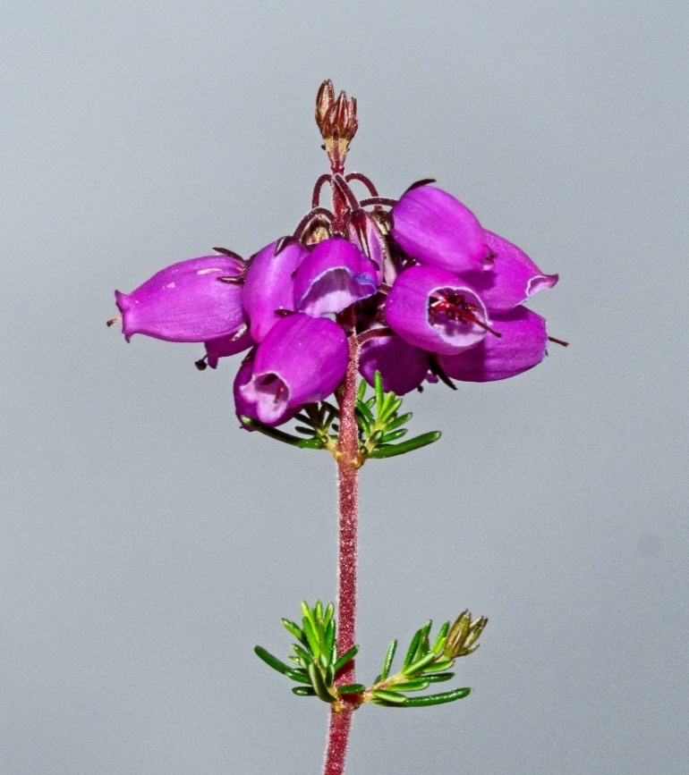
Figure 3. Erica cinerea flowers and leaves.
Results
The patch of E. cinerea was roughly rectangular, with dimensions 140 x 97 cm (area: 1.36 m²). A central Grid Reference was SD 29213 01543. Soil pH measurements were as follows: 4.01; 4.32; 4.15; 4.07; 4.12 (mean = 4.13). Associates of E. cinerea are listed in Table 1, the most frequent vascular taxa being Carex arenaria (Sand Sedge) and Festuca rubra (Red Fescue), followed by Chamaenerion angustifolium (Rosebay Willowherb), Holcus lanatus (Yorkshire-fog) and Rubus fruticosus agg. (Bramble).

Table 1. Associates of Erica cinerea at Ainsdale NNR
r = rare; o = occasional; f = frequent; a = abundant.
Taxon | English name | Frequency
Carex arenaria | Sand Sedge | f
Chamaenerion angustifolium | Rosebay Willowherb | o
Crataegus monogyna | Hawthorn | r
Dryopteris carthusiana | Narrow Buckler-fern | r
Festuca rubra | Red Fescue | f
Holcus lanatus | Yorkshire-fog | o
Pseudoscleropodium purum | Neat Feather-moss | a
Potentilla reptans | Creeping Cinquefoil | r
Rubus fruticosus agg. | Bramble | o
Veronica officinalis | Heath Speedwell | r

Discussion
Erica cinerea is a small shrub of thin, acidic, peaty or mineral soils in well-drained situations on dry and montane habitats and as an occasional under-shrub in open canopy Scot’s Pine (Pinus sylvestris) or oak (Quercus) woodland. It is also found on calcareous soils that are leached and acidic on the surface, as in this part of Ainsdale NNR. The low soil pH (mean 4.13) is attributable to the former presence of Corsican Pine (Pinus nigra subsp. laricio) plantation, which has acidified the upper soil horizons, while the open dunes mainly support calcareous soils (Millington et al., 2010; Proctor & Hodd, 2023). Ellenberg Indicator Values (Hill et al., 2004) show that E. cinerea is adapted to well-lit places or partial shade (L = 7), on soils of average dampness (F = 5), that have a mainly acid reaction (R = 2) and are relatively infertile (N = 2), while the plant is absent from saline sites (S = 0). These characteristics accord with the habitat of E. cinerea in the Ainsdale NNR firebreak. There are no National Vegetation Classification (NVC) descriptions in Rodwell (2000) that closely resemble the E. cinerea site, perhaps due to its recent history as a firebreak. The frequency of Carex arenaria (Sand Sedge) suggests a variant of SD12: Carex arenaria-Festuca ovina-Agrostis capillaris dune grassland, perhaps SD12b: the Holcus lanatus sub-community. This is associated with older dunelands where accretion is minimal and calcareous substrates have been leached over time. It is a community more often recorded towards the north and west of the country in wetter and cooler climates, as here (Rodwell, 2000). The presence of Chamaenerion angustifolium and Rubus fruticosus agg. indicate some similarities to OV27: Epilobium (now Chamaenerion) angustifolium community, which is dominated by C. angustifolium. Its commonest associates include Holcus lanatus and Rubus fruticosus agg. (Rodwell, 2000). Their presence could be due to past disturbance when the firebreak was created. During a study of the effects of scrub clearance and livestock grazing on habitats and plant communities in pine plantation firebreaks, Hunt et al. (2019) identified the same NVC communities as suggested in the current study, namely SD12b or, in their case, occasionally, SD12a: Anthoxanthum odoratum sub-community. They also pointed out that, where minimal management took place, a vegetation type resembling OV27 (sub-communities a – c) could be found. This community is typical of secondary woodland regeneration following clearance (Rodwell, 2000). The Plant Atlas 2020 distribution map (Procter & Hodd, 2023) shows that E. cinerea is widespread and almost ubiquitous in the north and west of Britain, though the ‘Lancashire’ coast is an exception, with only a few pre-1970 hectad records. However, early floras for the region (e.g. Ball, 1898-99; Dickinson, 1851; Green, 1933; Hall, 1838 and Savidge et al., 1963) make no mention of coastal occurrences of E. cinerea. As noted previously, when compiling an Inventory of Vascular Plants for the Sefton Coast, I did not find records of E. cinerea (Smith, 2023). NBN Atlas shows no Sefton Coast sightings, the nearest being on Scarth Hill, Ormskirk, Lancashire, in 1910. Similarly, there are no recent records of E. cinerea on iRecord for v.c.59. However, BSBI Maps show a pre-1930 occurrence in tetrad SD21V (Ainsdale dunes). This accords with an observation by C. Wild in 1914 (BSBI Database). The Database also reports E. cinerea in 1826 and 1914; the latter year by C. Waterfall in hectad SD31. This square includes some of the dune system but also a large area of hinterland, much of which is reclaimed peatland. A newspaper article by Eric Hardy, dated July 1940, describes a guided walk of the “British Empire Naturalists' Association” to an area of Formby Moss near Formby Hall, about 3 km from the coast, where “Bell Heather was flowering freely." This site Includes tetrads SD30E and SD31A and was later developed as part of Formby Hall Golf Course. Despite intensive botanical study (Smith, 2021), E. cinerea has not been seen on the Sefton dunes for well over a century. How it got to Ainsdale NNR is a mystery, possible transport of propagules being by livestock, deer or forestry vehicles. However, there is no specific evidence to support any of these suggestions. Long-buried seed might have been disturbed during the creation of the firebreak but Bannister (1965) provides little information on seed viability, other than: “Seed kept in a dry store showed some germination in the third year after collection.” He also reports that the seeds of E. cinerea are probably not distributed any great distance, seedlings commonly being found in the immediate vicinity of the parent. Based on its size, the patch is evidently several years old. The firebreak was established between 2003 and 2007 with occasional clearance thereafter of mostly birch (Betula) regrowth and intermittent conservation grazing, mainly by five Shetland cattle (Hunt et al., 2019). Hunt conducted field-work for her study in June 2017 but the route to her quadrats did not pass near the plant’s locality and she could easily have missed a smaller patch if it was not in flower. Also, since 2014, the cattle have rarely, if ever, been in this part of the firebreak, birch control by volunteers and staff being the main form of management (N. Hunt, D. Mercer, personal communications). Roe Deer (Capreolus capreolus) have greatly increased in recent years (personal observations) but it is not clear how they could have had contact with E. cinerea, the nearest modern record for the plant being at Skelmersdale, West Lancashire, about 30 km to the east (BSBI maps).
Acknowledgements
I am grateful to Natalie Hunt for drawing my attention to the find and to Dave Mercer who provided transport to the locality. Both gave helpful information on the site’s recent management history. Text changes and corrections were kindly suggested by Natalie and Mike Wilcox.
References
Ball, H. 1898-99. Botany of the Southport Society of Natural Science district with a preliminary list of the flora. Fourth report of the Southport Society of Natural Science, 39-53. Bannister, P. 1965. Erica cinerea L. Biological flora of the British Isles. Journal of Ecology 53: 527-542 Dickinson, J. 1851. Flora of Liverpool. Deighton & Laughton, Liverpool. Green, C.T. 1933. The flora of the Liverpool district. T. Buncle & Co., Arbroath. Hall, T.B. 1838. A flora of Liverpool. Whitaker & Co., London. Hill, M.O., Preston, C.D. & Roy, D.B. 2004. PLANTATT. Attributes of British and Irish plants: status, size, life history, geography and habitats. Centre for Ecology & Hydrology, Monks Wood, Cambridgeshire. Hunt, N., Mercer, D. & Oxbrough, A. 2019. Grazing and scrub clearance provide open dune habitat regeneration in pine plantation canopy gaps in Merseyside, UK. Conservation Evidence 16: 43-47. Millington, J.A., Booth, C.A., Fullen, M.A., Trueman, I.C. & Worsley, A.T. 2010. Distinguishing dune environments based on topsoil characteristics: a case study on the Sefton Coast. In: Worsley, A.T., Lymbery, G., Holden, G.V.J.C. & Newton, M. (eds) Sefton’s dynamic coast, pp. 116-130. Sefton Technical Services Department, Southport. Proctor, M.C.F. & Hodd, R.L. 2023. Erica cinerea Bell Heather. In: Stroh, P.A., Walker, K.J., Humphrey, T.A., Prescott, O.L. & Burkmar, R.J. Plant Atlas 2020. p. 738. Princeton University Press, Princeton & Oxford. Rodwell, J.S. (ed) 2000. British plant communities Volume 5. Maritime communities and vegetation of open habitats. Cambridge University Press, Cambridge. Savidge, J.P., Heywood, V.H. & Gordon, V., (eds) 1963. Travis’s flora of South Lancashire. Liverpool Botanical Society, Liverpool. Smith, P.H. 2021. Wildflowers of the Sefton Coast. Lancashire & Cheshire Fauna Society, Rishton. Smith, P.H. 2023. An inventory of vascular plants for the Sefton Coast, 2023 revision. Unpublished report.
Phil Smith

