NASA Technology | How was it created? | Why is it important? | Why would you want to invest in it?
Firefighter Gear


Freeze Drying Technology
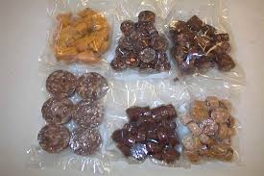
Water Purification
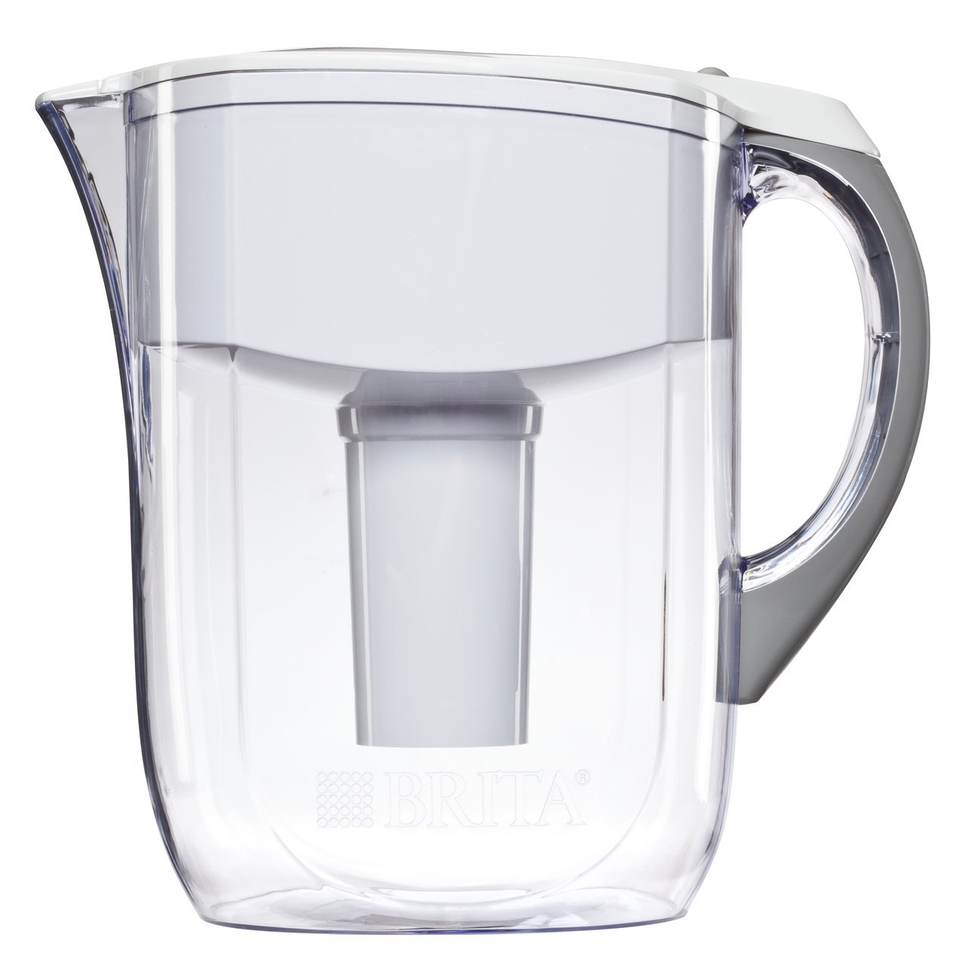
Memory (Temper) Foam
