Click to replace typing
*Add a fact
Insert facts here
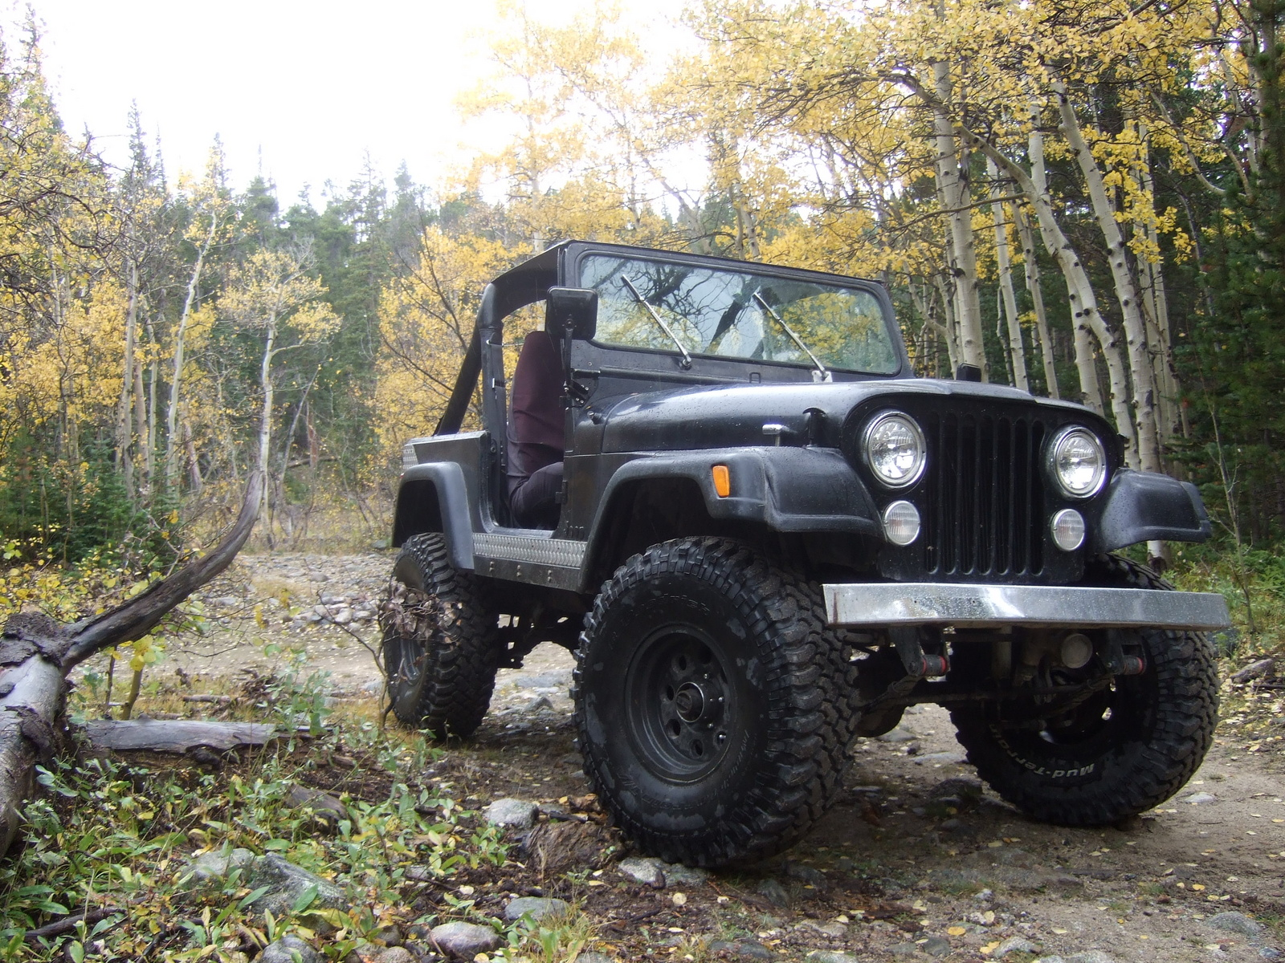
Click to replace typing
These text boxes can be widened or stretched

Click to replace typing
*Click to replace typing
*Add another point here
* Another fact here
Timeline Instructions
- To delete these instructions, click the text box and press the DELETE key.
- To replace text in a timeline event, click the arrow text object, select the existing text, and begin typing.
- To move a timeline event, drag the arrow text object to the location you want.
- To create additional timeline events, copy and paste the arrow text object you want, and then drag the object to the location you want.
- To replace dates on the timeline, click the timeline text box and use the TAB key to select the dates you want to change. To add additional dates on the timeline, point to Insert on the Table menu, and then click Columns to the Left or Columns to the Right.

Click to replace typing

Timeline Title
1100 |  | Date | Date | Date |  | Date | 1950-Present

Click to replace typing

Click to replace typing

