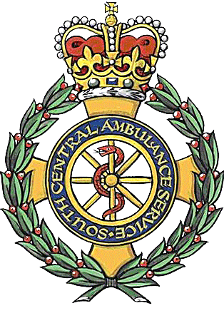

Public Access Defibrillators

South Central Ambulance Service NHS Foundation Trust, SCAS, has adopted the use of PADs, public access defibrillators. PADs are being adopted throughout the United Kingdom by most ambulance trusts.
They are a method whereby the public can have the ability to gain access to a defibrillator whilst an ambulance travels to the patient’s location. The UK resuscitation council have said that any person can use an Automated External Defibrillator and training is not required, as they are so easy and safe to use.
So how does this work. The local community purchase a defibrillator and a cabinet, the cabinet may or may not have a combination lock, SCAS prefer the cabinet to be secure, as this ensures that the ambulance service is called when the defibrillator is needed.
Once the cabinet is installed and the location is decided by the purchasers and community, they inform the local ambulance officer responsible and give the officer the location including post code, whereabouts on the building the cabinet is, and the access code. The maintenance and replenishment of equipment is the responsibility of the local community so the contact details of a responsible person will also be required.
Once the ambulance officer has these details he or she will pass them onto the control system, this then means that any person requiring the defibrillator within 300 meters of the cabinet (although this distance can be adjusted to suit local needs) who has another person with them can be given the code and location of the cabinet, then talked through how to use it if required.
Costs and running costs are, defibrillator with cabinet approximately £1400 + vat, defibrillator pads are single use and cost approximately £15 + vat, battery £125 + vat approximately. The battery should last 5 years or 200 shocks and the machine requires no maintenance and is guaranteed for 10 years once registered with the local ambulance trust. The cabinet has a heater that requires mains electricity, just during very cold weather and this is approximately £30 per year in electricity, but this is very dependent on weather. All these figures are based on the Ipad SP1 defibrillator and cabinet supplied by Welmedical

Stephen Cartwright
CRLATO PADs

